Othello User Manual

Created by: Team Henry



Contents

1.0 Introduction 3

2.0 Getting Started 3

2.1 Registering 3

2.2 Logging In 3

3.0 How to play 3

3.1 Making a play 4

3.2 Timers 6

3.3 Ending the game 7

3.4 Keeping Score 7

3.5 Turn indicators 7

3.6 Pass Button 7

3.7 Quitting 8

3.8 Invalid moves 8

4.0 Leaderboard 8

# Introduction

The game Othello is a strategy game that takes a minute to learn and a lifetime to master. ™ Using two-sided game discs and your wits alone you battle it out with one other player. The goal is simple, have more discs on the board with your color face up than the other player, however getting that higher number may be easier said than done.

# 2.0 Getting Started

Othello requires each player to register before playing.

## 2.1 Registering

When launching the application, you will be prompted for a username and password. You get this information by registering first.   
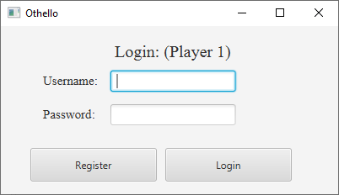

1. Click **Register**
2. Type in a username and a password in the appropriate boxes
   1. Usernames must be 5 alpha-numeric characters
   2. Passwords must be 5 digits
3. Repeat steps 1 and 2 for player 2 if needed
4. Once registration is complete the menu will launch.
5. Click **Play** **Game** to play a new game or **Statistics** to view the leaderboard

## 2.2 Logging In

Note: You must be registered before you can login

1. When prompted each player must provide the correct username and password in the appropriate boxes
2. Click **Login**
3. If successful, the **Main Menu** will launch
4. Click **Play Game** to play a new game or **Statistics** to view the leaderboard

# 3.0 How to play

Starting with the player that is using the black sides you take turns capturing (turning over) each other’s discs. If you are unable to do that you skip your turn

## 3.1 Making a play

Each turn you must find an available spot adjacent to your opponent’s color to play your disc. This spot must “touch” the square your opponent’s disc is in, this can be horizontal, vertical, or diagonal. After placing your disc, you turn over your opponent’s discs that are in between the existing disc that was on the board and the new disc you have placed, thus “capturing” it. Sometimes this is one disc, sometimes it’s many discs that you capture in one move. If the field, you place the disc in does not result in capturing the opponent’s disc(s) that is not a legal move. If you are unable to find a field where an opponent’ disc would be captured your turn is forfeited and play is passed to your opponent.

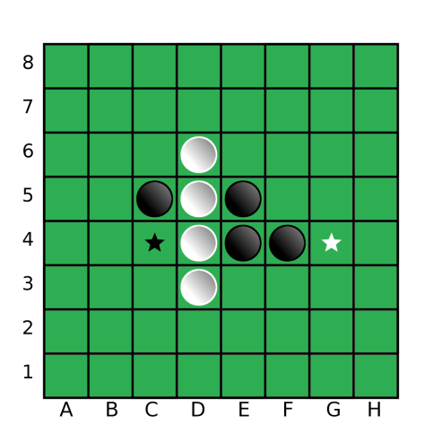

Figure 1 Make a move example for both sides

For example, in the graphic above if it is white’s turn, white places a disc in G4 capturing E4 and F4 in the process. If it was black’s turn black places a disc in C4 that would capture D4.

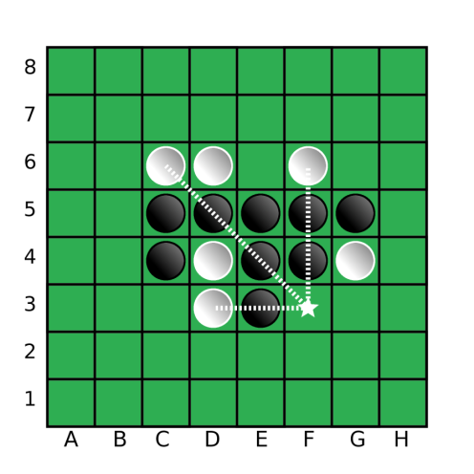

Figure 2Advance strategy for capturing multiple discs

For example, during white’s turn a disc is placed in F3. This move allows three straight lines to be created with many black discs in between. From this move white will capture D5, E4, E3, F4, and F5.

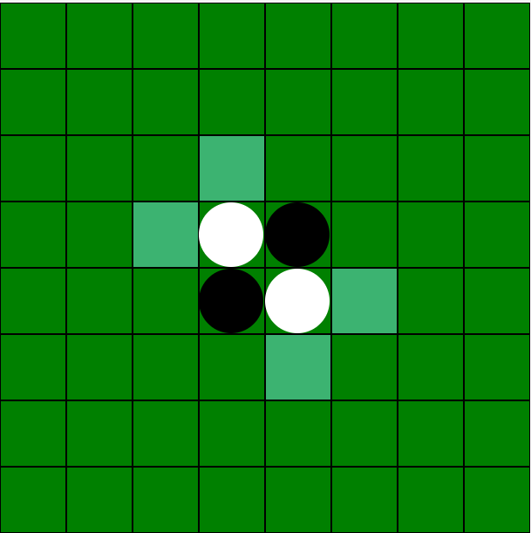To assist with making a valid move certain squares are colored more lightly.

Figure initial game board

## 3.2 Timers

The timer is set when starting a game from the Main Menu screen. The default time limit is 120 seconds. There is no limit to the length you can set.

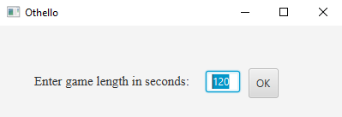

Figure 4 Game asks the players to set the Time limit of the game.

Each player has a timer above their scores that indicate the number of seconds remaining to finish the game. As a player makes a move and play passes to the other player their timer will pause.

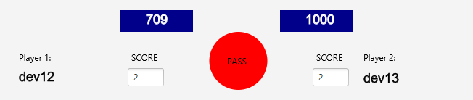

Figure 5 Showing the timers

If a player’s timer reaches 0, they are no longer allowed to play, and the final score is counted. E.g. figure 6shows the time for player “sad11” has ran out. So, the second player “djp12” has won the game.

* **No** - Exits the game
* **Yes** - Starts a new round with the existing players

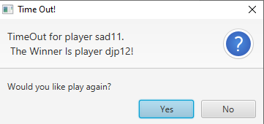

Figure 6 dialog box when The Time runs out for one player

## 3.3 Ending the game

This way of play continues until all the spaces on the board are filled, timer runs out, or there are no moves for either player to make. The figure 7 shows the scenario when all the spaces are filled on the board.

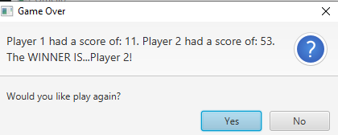

Figure A sample of end game dialog box

## 3.4 Keeping Score

As each player take their respective turn the points are calculated by their names

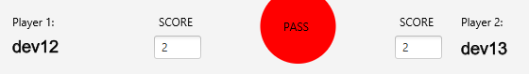

Figure showing current score for each player

## 3.5 Turn indicators

During the game, each player can find out whose turn it is by looking at the down right of the window. The following image shows the turn indicator

## 3.6 Pass Button

During the game, there are scenarios, that there are no valid moves for a player who owns the turn. In these scenarios the player should use red pass button to give the turn to the other player. This happens by pressing red button shown in the below figure:

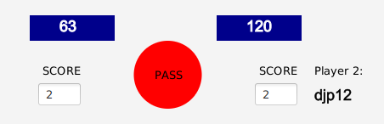

Figure pass button

## 3.7 Quitting

A player can decide to quit during his/her turn. The software will ask the player whether he wants to quit. Clicking on No will continue the game and clicking yes will declare the opponent as the winner of the round as depicted in figure 10.

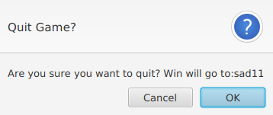

Figure quit dialogue box

## 3.8 Invalid moves

As demonstrated in figure 3, each player is given specific options to place a new disc. Placing disc at other places is not allowed by the rules of the original game and the system.

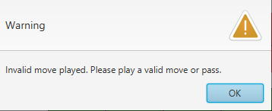

Figure 11 screenshot of the error player that player will see by attempting an invalid move

Nonetheless, If the player attempts to place disc at invalid places system shows a warning depicted in figure 11. By pressing OK, the player can continue and place a disc at valid squares.

# 4.0 Leaderboard

The system tracks each player’s wins and losses. Each can view the leaderboard to see the top players. To view the leaderboard, click the Statistics button from the Main Menu.

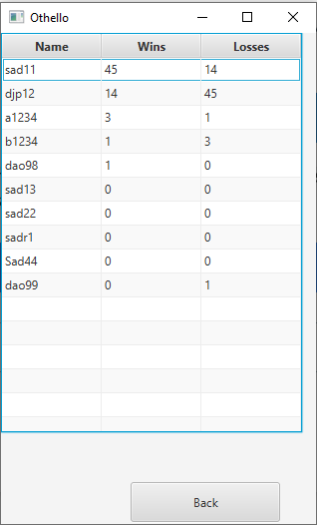

Figure 2 a view of leaderboard